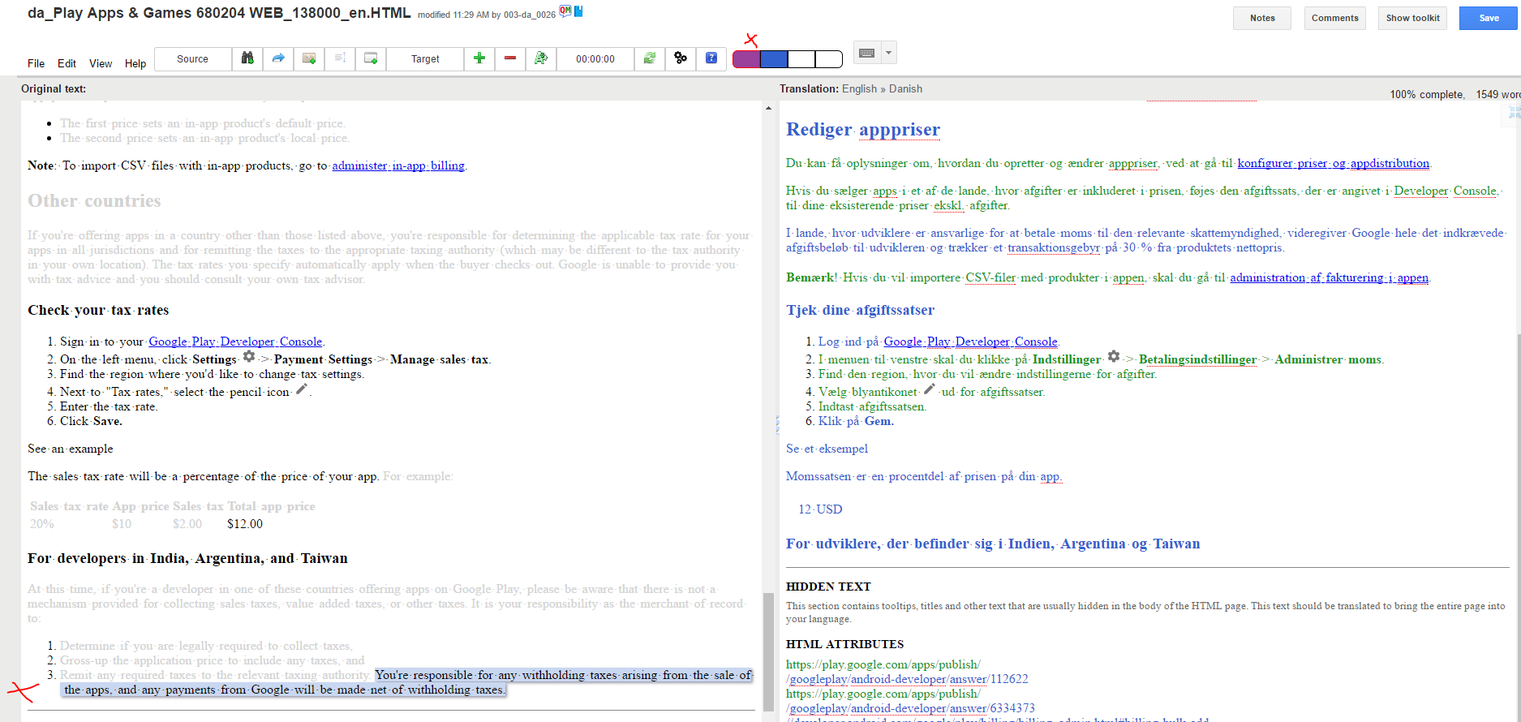

Removing the purple segments from view also removed the marked 100% match from the target side.

\*\*\*

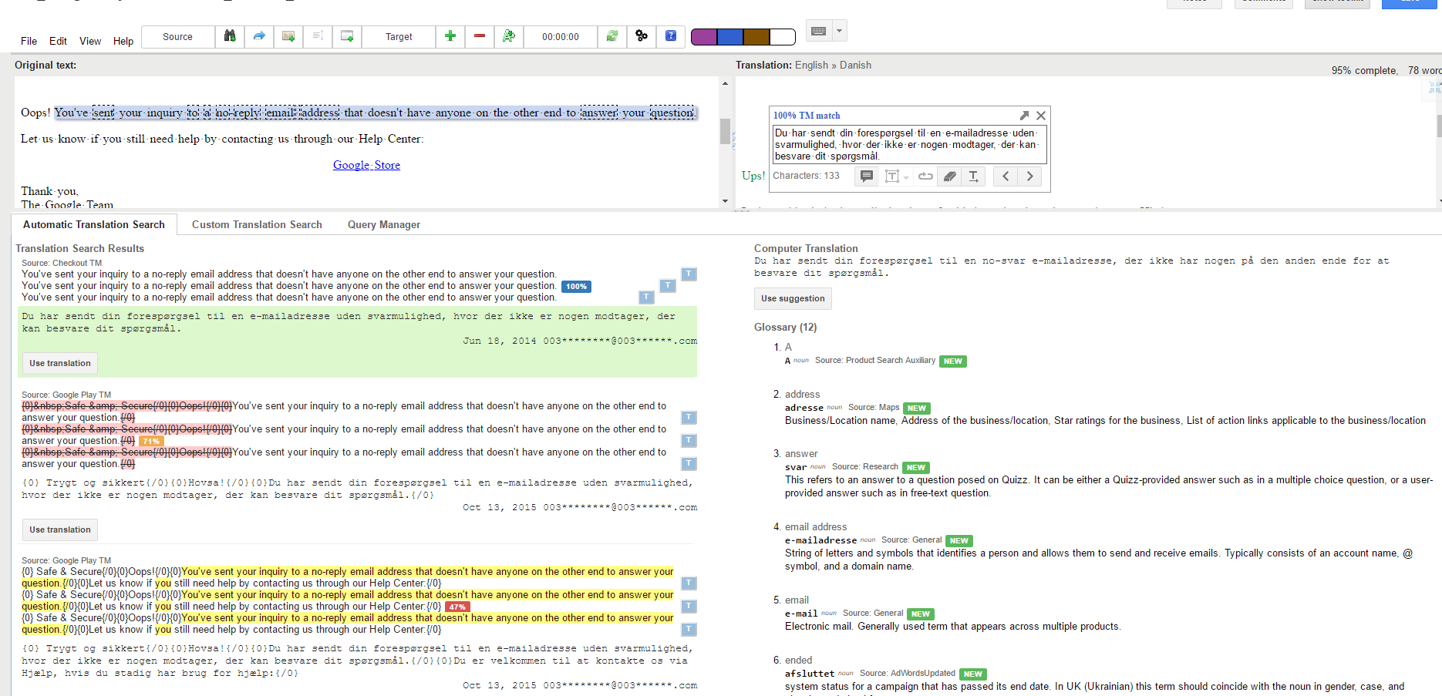

Many source messages in Automatic Translation Search. Occasionally there are none – that is actually more common.

\*\*\*

When using Custom Translation Search in Toolkit, the Glossary shows results for one word at a time from the selected segment when pressing Enter (and not the phrase entered in the Toolkit search field, though it may be visible in a super short blink).

\*\*\*

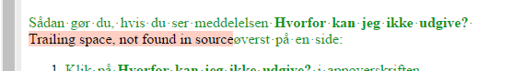

These messages were merged, but the QA-function doesn’t seem to realise that.

\*\*\*

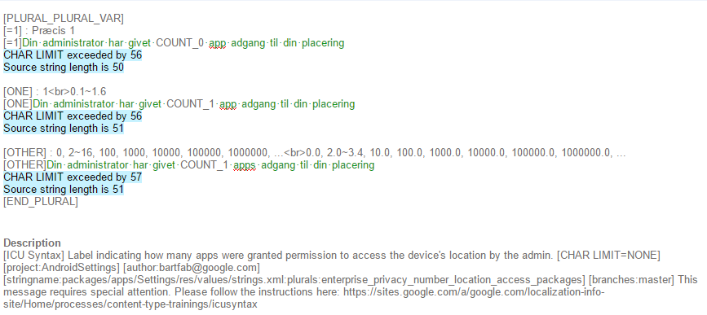

“CHAR LIMIT=NONE” is taken a bit too literally

\*\*\*